**Interview Question and Answer**

1)What is Intermediate Operator in Java 8?

-Intermediate Operator are the method which are used to process the element of the Stream and it does not return us the value but it will return us

stream or process stream.

EX: filter(),Map(),FlatMap(),Disctinct(),Skip(),Limit ().

2)What is Terminal operator in Java 8?

-This are the method which takes i/p stream and return us the values after processing.and once a terminal operation is called, the stream cannot be reused for further operations.

E0X: findFirst(),COunt(),ForEach(),Collect().

**Why stream is lazily evaluated-Because of Intermediate operator we don’t produce the result until terminal operator is involved.**

3)What is ACID Property?

--Transcation:its a unit of work against the db in logical sequence

-To Ensure the Integrity of Data it always Follows ACID Property

AUTOMICITY:Either all operation of transcation are reflected properly in db or none of all (rollback)

Consistancy:Integrity Constriant must be maintain before and after transcation

Isolation:Ww will perform the operation in cuncurrently but in squential manner so that other transcation dont know about other and also they dont interfiar

with each other

Durability:If any system error occur our changes must be persist irrespective of system failure we have recovery manger fot this.

4)Describe the purpose of database indexing and types of indexes in MySQL?

Database indexing is a technique used to optimize the retrieval of data from a database table. The primary purpose of indexing is to improve the speed of data retrieval operations, such as SELECT queries, by creating a data structure that allows the database management system (DBMS) to quickly locate the rows that match a specific condition. Without indexing, the DBMS would have to scan the entire table to find the requested data, which can be inefficient, especially in large tables. Here are some key purposes of database indexing:

-Improved Query Performance:

-Faster Sorting and Grouping:

5) Difference Between

-HashMap: Its not Thread Safe so performance is high and multiple thread can operate on map.

-single null key and multiple null value allowed

-Hash Table:

-Its Thread Safe so performance is low as thread need to wait to get lock. It will lock entire bucket.

-not even single null key and null value are not allowed

-Synchronized Map:

-Its Thread Safe so performance is low as thread need to wait to get lock. It will lock entire bucket.

- null key and multiple null value allowed

-Concurrent HashMap:

-Its thread safe performance is high as it using segment lock not entire bucket is locked.

-null insertion of key and value are not allowed.

6) Authentication and Authorization? What is Auth 2.0?

Authentication: Who you are. what ever I am pretending I need to prove by providing username password or multifactor authenticate or physical card.

Authorization: what I can do.so what ever the permission I am having user need to validate

- 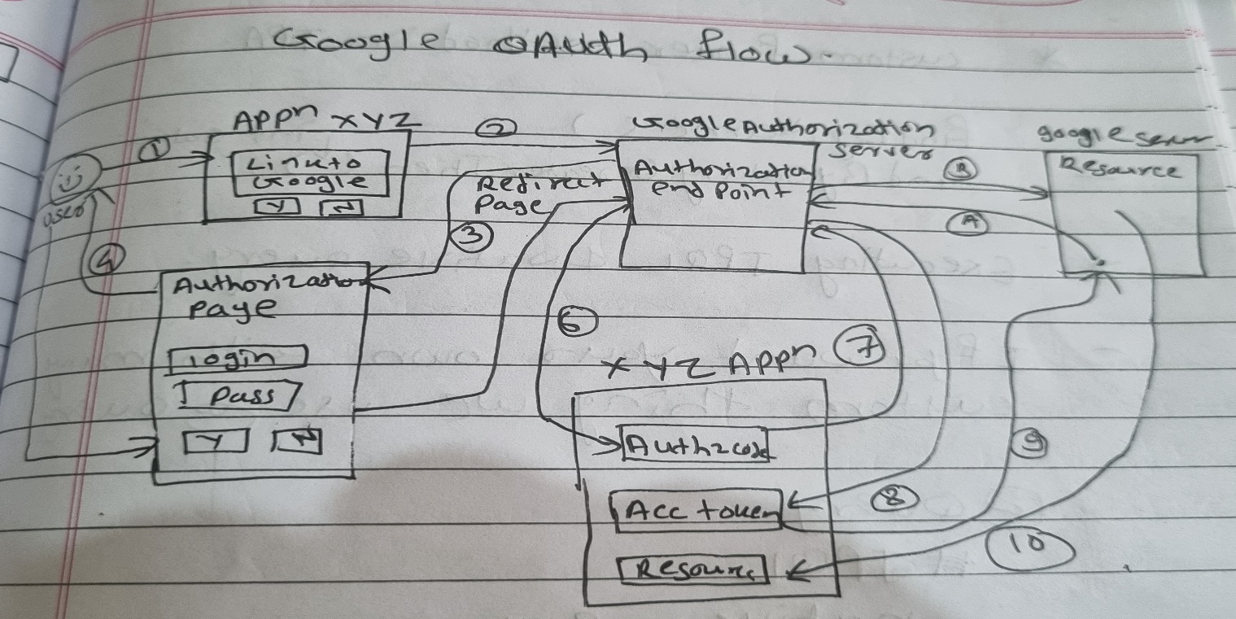

7) Scope of Bean?

-singleton

-prototype

-session

-request

-global

8)Find duplicate from array using stream ?

- int[] arr={1,2,1,3,2,5,7};

Either I can use filter with set and either I can use collectors.grouping by

1. using filter

*List<Integer>l=Arrays.asList(arr);*

*Set<Integer>s=new HashSet<>();*

*List<Integer>collect = l.stream().filter(x->!s.add(x)).collect(Collectors.toList());*

*Collect.forEach(System.out::println);*

II)Using collectors.groupingby

int[] arr={1,2,1,3,2,5,7};

*List<Integer>l=Arrays.asList(arr);*

*l.stream().collect(collectors.groupingBy(i->I,Collectors.counting()).entrySet().stream()*

*.filter(entry->entry.getValue()>1).map(entry->entry.getKey()).collect(Collectors.toList());*